**Crosstabs**



**Jenis Kelamin * PCR**





**Usia * PCR**





**Gejala * PCR**





**Rontgen * PCR**





**Crosstabs**







**Explore**

**PCR**







**NPar Tests**

**Mann-Whitney Test**





**ROC Curve**



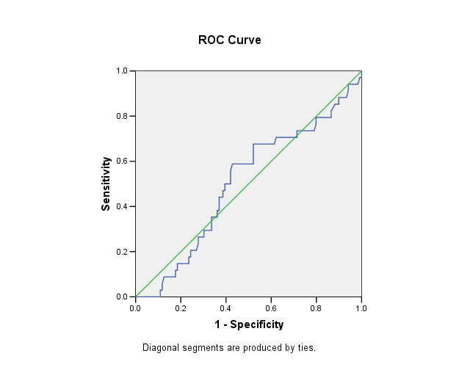







**Hasil Tabulasi Silang Antara Cutoff NLR dan PCR**

**Crosstabs**







**Hasil Penghitungan Sensitifitas, Spesifisitas, NDP, NDN, RKP, dan RKN Cutoff NLR Sebagai prediktor COVID 19**

|  |  |  |  |
| --- | --- | --- | --- |
| NLR | PCR | | Total |
| Positif | Negatif |
| >1,625 | 20 | 58 | 78 |
| <1,625 | 14 | 61 | 75 |
| Total | 34 | 119 | 153 |
| Sn | =0.588 |  |  |
| Sp | =0.513 |  |  |
| NDP | =0.256 |  |  |
| NDN | =0.813 |  |  |
| RKP | =1.207 |  |  |
| RKN | =0.803 |  |  |

**Hasil Tabulasi Silang Antara Cutoff NLR dan PCR (3.13**

**Crosstabs**







**Hasil Penghitungan Sensitifitas, Spesifisitas, NDP, NDN, RKP, dan RKN Cutoff NLR Sebagai prediktor COVID 19 (3.13)**

|  |  |  |  |
| --- | --- | --- | --- |
| NLR | PCR | | Total |
| Positif | Negatif |
| >=3.13 | 9 | 34 | 43 |
| <3.13 | 25 | 85 | 110 |
| Total | 34 | 119 | 153 |
| Sn | 0.265 |  |  |
| Sp | 0.714 |  |  |
| NDP | 0.209 |  |  |
| NDN | 0.773 |  |  |
| RKP | 0.926 |  |  |
| RKN | 1.029 |  |  |